

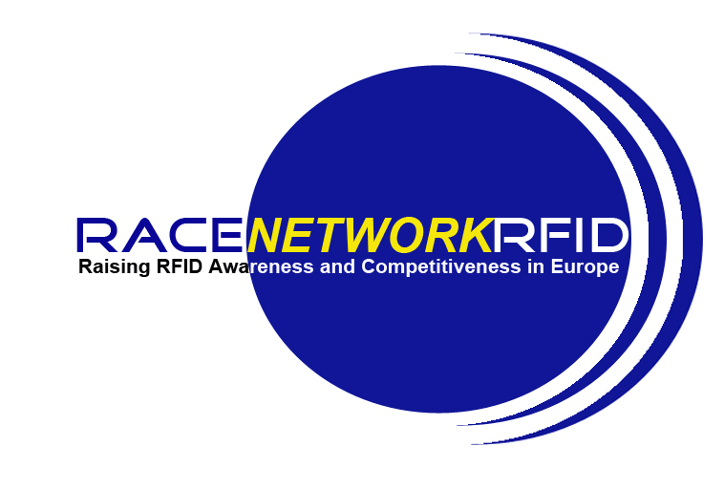

RACE networkRFID
Raising Awareness and Competitiveness in Europe

Associate Member Application Form

Name of Organisation :
Country:
Legal address:

Official web site:
Contact Person:
Title:
Name:
Position:
e-mail:
Tel:
Fax:
Description of your organisation and work area (highlighting relations to RFID)

Motivation for joining the network

RACEnetworkRFID operates the following work packages which are opened to all members. Please tick ✓ the ones you would like to join:

WP1 - Business Monitoring, Policy Liaison and Collaboration ◻
WP2 - Technology Roadmap and Market Analysis ◻
WP3 - Applications and Project Deployment ◻
WP4 - Harmonisation of Related Projects ◻
WP5 - Public Awareness ◻
WP6 - Industry sectors and SME Awareness ◻
WP7 – Dissemination ◻
WP9 - Government liaison ◻

RACEnetworkRFID is continually looking for local materials that could be used on a European basis. Can you help with any of the following ? Please tick ✓ as appropriate

1/. Non-commercial video/DvD materials for our web site ◻

2/. Case studies and application stories ◻

3/. List of SME organisations in your country ◻

4/. Other prospective RACEnetworkRFID members in your country ◻

5/. Non-commercial training, education or awareness materials ◻
that you would be prepared to share with the network

----------------------------------------------------------------------------------------------------------------
To submit your application, please remember to send this Form to :
race-networkrfid-support@ercim.org
----------------------------------------------------------------------------------------------------------------

Thank you for your interest in RACE networkRFID

Reminder:
Associate Members are organisations joining the network after its contractual start.
Associate Members are invited to participate in the RFID in Europe activities of workpackages of their choice and to contribute to the different network activities.
Associate Members receive no funding for their participation or travel costs associated with the network. The degree of participation of Associate Members to the network activities is up to each institution and is on a voluntary basis.

